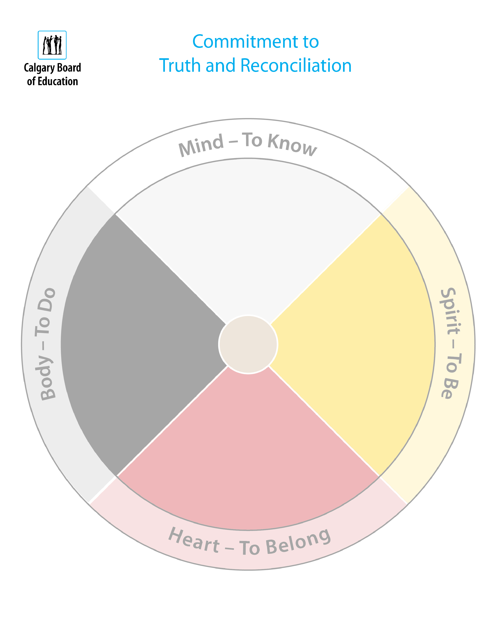

In recognition of National Indigenous Peoples Day,

and in alignment with the CBE Education Plan,

Valley Creek School

acknowledges and supports the Truth and
Reconciliation Commission
of Canada
’
s (TRC) Calls to Action, and makes the following
commitment to action for the 2026
-
school year
:
2027

Valley Creek School will strive to create a culture of care that fosters
genuine, intentional, and authentic learning. We will create
opportunities for students and staff to engage the body through
movement
,
place
-
based learning

and active
engagement

in
assessment
;

and engage the heart by strengthening relationships,
belonging, and meaningful connections with community and place
.

Optional

Insert School

logo

